EXPERIMENT-12
12)Perform a 270-degree rotation clockwise along the y-axis for the given image.
CODE
import cv2
from tkinter import Tk, filedialog

root = Tk()
root.withdraw()

file = filedialog.askopenfilename(
title="Select Image",
filetypes=[("Image Files", "*.jpg *.jpeg *.png")]
)

img = cv2.imread(file)

if img is None:
print("Image not found")
else:
rotated = cv2.rotate(img, cv2.ROTATE_90_COUNTERCLOCKWISE)

cv2.imwrite(r"C:\Users\Admin\Desktop\rotated_270_image.jpg", rotated)

cv2.imshow("Original Image", img)
cv2.imshow("270 Degree Rotated Image", rotated)

print("270-degree rotation completed successfully")
print("Saved on Desktop as rotated_270_image.jpg")

cv2.waitKey(0)
cv2.destroyAllWindows()

b) INPUT
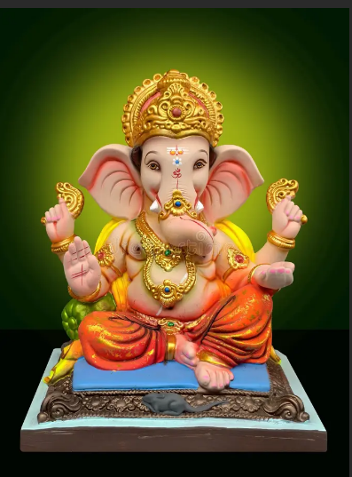
c) OUTPUT
